Student Fee Advisory Committee
Meeting Agenda March 23, 2023

Reminder: All documents available in Shared Drive: SFAC
- Call to Order 3:08pm
- Introductions / Roll Call
  - Present-Amber Blakeslee, Jenn Caps, Chrissy Holliday, , Jim Woglom, Juan Guerrero Geraldo Hernandez, Sebastian Taylor, non-voting- Francisco Valdez, Liz Cano Sanchez and Sandy Wieckowski
  - Absent-Tashanae Burns-Young, Marie-Claire Desplancke,
  - Guest-Katie Koscielak, Morgan King, Rhiannon Red Bird, Morgan Baker

- Public Comment
- Approval of Meeting Minutes from February 23, 2023
- Proposed HEIF Revisions
  - HEIF is a fund championed by students to collect money where students can vote on using for energy. Original intent was to get solar panel. Original name designated is as energy independent. Over the years, the organization has used the funding for other projects beside energy independence. The group wants to alien the name with the mission and value statement that aliens with the needs of the campus community and student feedback.
  - Students fees fund HEIF, per semester $8.00 part-time, $13.41 full-time
  - Change the name to SHIFT Sustainable Humboldt Innovative Futures Trust
  - About HEIF (website https://heif.humboldt.edu/about-heif)
  - Revisions to HEIF Mission / Vision / Values Statements (end of document)
  - The HEIF committee will work on a communication strategy and marketing plan for rolling out the name and mission change. Recommendation from SFAC, utilize campus media outlets
- Action item-Gio moved to revise the HEIF mission, Jenn seconded. Vote 7-aye, 0-no, 1-abstain
  - Amber & Gio will draft a memo to send the recommendation to the President for approval.

- Student Health Fee - 2023-24 MMI Increase Proposal
In 2018, the Student Health Fee increase included approval to annually increase the Student Health Fee by the Milliman Medical Index (MMI), an inflationary index applicable to medical costs, with an approved justification of need. Student Affairs will provide an analysis and justification to the Student Fee Advisory Committee as early as possible in the spring semester; SFAC will then forward its recommendation to the President for approval.”
  - The MMI has not been implemented over the past 3 years due to the financial constraint COVID had imposed on student’s finances.
  - Propose a $15 per term increase to cover the current budget deficit.

  - Motion to increase the Health Service fee by the MMI was by Gio, Sebastian second, vote 5-aye, 0-no, 2-abstain. Gerardo stepped out of the meeting. The motion was resubmitted, Gio made the motion, Sebastian seconded. vote 6-aye, 0-no, 2-abstain
  - Amber & Gio will draft a document recommending the fee increase for the Health Service fee
- Next Steps and Action Items
  - AS election April 17th, AS fee increase posted new flyer and open forum next week

Future agenda items:
- Housing and Dining rate increases
- Summer Fee Rates
- Jack Pas Fee definition revision (April 6th meeting)
- Committee to create a business process for changing the use of an existing fee or changing the fund name
- Student Body Center Fee Increase (Year 2 of past increase not implemented)
- Placing a annual index increase on all campus mandatory fees to help with rising inflation

Meeting adjourned at 3:56pm

EWORKING HEIF MISSION/VISION/VALUES SPRING 2021
Originally drafted by working group April 8, 2021; endorsed by Committee May 5, 2021

HEIF Committee Recommendation for change:
The HEIF Committee formally considered the proposed changes which were put forth by a Committee working group, gave feedback which was incorporated, and then endorsed the proposed changes in full on 5/5/2021 (see meeting minutes here), with the following motion and unanimous vote:
"Motion to approve mission statement change, new vision statement, new values statement and recommended Name change #3 ”Sustainable Humboldt Innovative Futures Trust”. Motion put forth by Nayre Herrera (student), Second by: Liza Boyle (faculty).
Vote in favor: 7, Vote against: 0, Abstains: 0. Motion Passes."

Why is the Committee recommending a move away from the language of “energy independence” as the foundational value/nomenclature for HEIF?
Energy independence is a notion generally understood to be when an entity generates their own energy, i.e. does not import it from external sources. However, this can be accomplished by methods or means that have significantly harmful impacts to the environment and people, such as fracking, petroleum fuel extraction, coal mining, etc. Therefore, in the spirit of Cal Poly Humboldt’s longstanding commitment to sustainability, the Committee recommends that using “energy independence” as the sole and primary mission of HEIF is not in alignment with campus goals, priorities, and past and ongoing HEIF projects, which means this phrase is significantly confusing and inaccurate. To this end, we recommend removing this terminology from HEIF’s name and mission statement. Furthermore, in the vein of the initial Associated Students ballot proposal which underscored a need to procure or generate clean, renewable energy for Humboldt, the Committee hopes to highlight that the state of CA now has mandates for renewable energy and therefore it no longer seems appropriate to put this burden on a fund generated by student fee money. In addition, the proposed revisions below expand this fund’s mission to include additional project scopes that comprehensively honor sustainability as a broader theme and have been accomplished by the fund all along anyway.

Recommended name change:
Sustainable Humboldt Innovative Futures Trust (SHIFT)

Recommended revised mission/purpose statement:
With funds made up of student fee money, SHIFT supports, coordinates, and implements innovative campus sustainability projects.

Recommended new vision statement:
SHIFT accomplishes this mission by advancing student ideas that promote sustainable modes of transportation, increase clean energy generation and efficiency, increase water conservation, restore habitat, promote social/environmental/food justice, and reduce waste. Portions of the fund also support education and behavior change initiatives, student aid, and student internships.

Recommended new values statements:
- Student Involvement: SHIFT will incorporate students heavily in the governance of decision making by ensuring a majority of Committee voting seats are held by students and by utilizing strong student involvement in projects. SHIFT should encourage projects that originate from and align with curricular and academic projects.
- Innovation: Projects funded and implemented by SHIFT should advance beyond the current standards, codes, permitting requirements, and safety conditions mandated by the state, the CSU, the campus, or other regulatory agencies.
- Sustainability: SHIFT will rely on the Cal Poly Humboldt definition of sustainability established by the Humboldt Advisory Committee on Sustainability (HACS) in 2018 as follows “Sustainability is the recognition that humanity is a part of the natural world, not separate from it, and that healthy social and economic systems depend on the health and resilience of ecological systems.”
- Accountability & Transparency: SHIFT will publish and disseminate information regarding opportunities for student involvement, budget, and aspects of project success and failure through a variety of media.
- Assessment & Measuring Success: SHIFT will utilize consistent methods and protocols at routine milestones for measuring and reporting quantitative and qualitative results from projects and publish these findings on the website.
- Justice: SHIFT aims to promote projects that address social, environmental, and food justice issues on campus and to be equitable in recruiting diverse involvement at all levels of project management.

Pre-existing HEIF Website Goals: As reviewed by working group on 3/25/2021 & 4/1/2021 & 4/8/2021

- The HEIF will achieve its mission through projects that are developed by students and, to the extent possible, implemented, monitored, and maintained with strong student involvement.
- The HEIF will require accountability by measuring and reporting quantitative and qualitative results, as well as levels of involvement by students and other participants, in all its projects.
- The HEIF will strive to make its projects derive from and be connected to the curriculum of the university.
- The HEIF will support the dissemination of information about its projects through public outreach and educational activities.
- The HEIF will seek to publicize accomplishments and experiences associated with its program and projects through a variety of media.
Bylaws goals for the Committee:
(i) Encourage the integration of HEIF projects into academic curriculum
(ii) Make recommendations for project topics to proposal authors
(iii) Provide assistance to parties involved in developing project proposals
(iv) Approve projects for HEIF funding
(v) Participate in the development and implementation of approved projects
(vi) Ensure collection and evaluation of project performance data
(vii) Maintain HEIF spending records
(viii) Summarize HEIF activity in an annual public report
(ix) Develop and update an informational website

Student Health Fee - 2023-24 MMI Increase Request

Background
In 2018, the Student Health Fee increase included approval to annually increase the Student Health Fee by the Milliman Medical Index (MMI), an inflationary index applicable to medical costs, with an approved justification of need. As stated in President Rossbacher’s fee approval memo, “To increase the fee by the MMI, the University Budget Office, in consultation with Student Health and Wellbeing Services and the Vice President for Student Affairs, will provide an analysis and justification to the Student Fee Advisory Committee as early as possible in the spring semester; SFAC will then forward its recommendation to the President for approval.”

Student Health Fee Rate, Budget History and Justification of Need
In an effort to keep student fees as affordable as possible, particularly during the height of COVID-19, no MMI increases have been applied to the Student Health Fee since 2019-20, as reflected in the table below. The 2022 MMI inflationary increase is 4.6%. Applying MMI to the current Student Health Fee will increase the fee rate by $15 per term, from $333 to $348.

Student Health Fee | 2019-20 | 2020-21 | 2021-22 | 2022-23 | 2023-24  Proposed
Term Fee Rate | $333 | $333 | $333 | $333 | $348

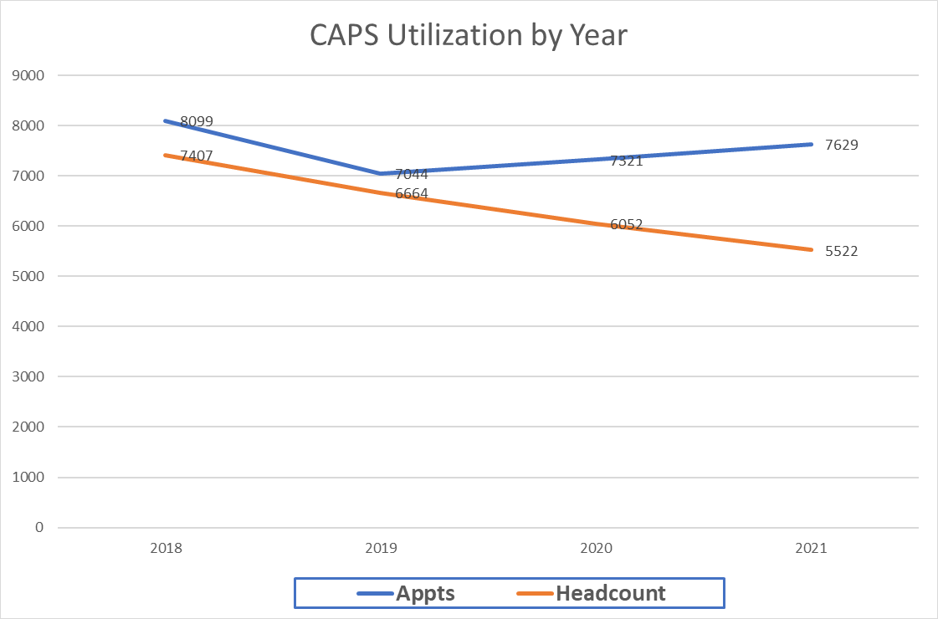
In combination with significant recent cost inflation, particularly in relation to medical supplies and the increased costs of attracting and retaining medical and mental health providers, and declining enrollment until this year, Student Health and Wellbeing Services has been operating with a significant structural budget deficit over the past several years. One-time federal relief funding during the pandemic provided key support to maintain services to students over the past few years, however, this one-time funding has been spent. At the same time, student health needs are growing at Humboldt and across the nation. The campus must find ways to meet student service needs in our community, which already struggles with limited medical and mental health providers.

This graph provides insight into utilization of our campus CAPS services, with significant increases in appointments, even during the pandemic, with declining enrollments and limited presence on campus.

Anticipated enrollment growth and fee revenue in 2023-24 will improve the budget outlook, but not fully address the structural budget deficit, resulting in the need to increase the fee by MMI in order to maintain critical medical and mental health services for our students.

Student Health & Wellbeing Services Budget | 2019-20 | 2020-21 | 2021-22 | 2022-23 | Estimated 2023-24*
Surplus / (Deficit) | (522,070) | (1,221,078) | (943,034) | (1,221,949) | (240,254)
Deficit w MMI |  |  |  |  | (34,254)
*Numbers subject to change with Spring 2023 budget planning

